Los Angeles Area Vehicle Collisions between 2009 and 2013

Andrew Rosalino

Aylin Ignacio

Sareena Grajeda

Phan Tu Dang

Computer Information Systems 3200

California State University, Los Angeles

**Abstract:**

The project will focus on a data set consisting of information about vehicle collisions that occurred in the Los Angeles area between the years of 2009 through 2013. The data set will include the severity of the collision, the time of occurrence and the date. We will be able to map out an average of the most collisions that occur in specific areas, and see what factors in those areas could be accountable for the higher number of collisions, and allow us to perform a prediction of collisions based on the data. We will see if there was any alcohol involved during the collision and how they overall played a role in the collisions. We can also see what the weather conditions were at the time of the collision and see if there is a correlation between weather conditions and collision types. We will also see if the road conditions somehow correlated to the collisions as well. The results did show us that weather did play a major part as to the severity of the collisions as well as certain road conditions. We were also able to see the number of incidents that occurred per year, the amount of injuries that occurred as well as their severity, along with deaths per year. We also included the results of the deaths per year and the number of those involving alcohol.

**1. Introduction**

We chose this topic because we found it interesting to see how many collisions occurred in the Los Angeles area. We wanted to see if there were any reasons such as alcohol involved during these collisions. Also how many people died as a result of these collisions, or what kinds of injuries they obtained if they were serious injuries or minor ones. Also since the weather in Los Angeles is also almost always sunny, we wanted to see if weather played a role in these incidents. We do know that when it rains in Los Angeles people become the worst drivers because they are not used to driving in the rain so it was interesting to see how rain seemed to play a huge role in these collisions. We also saw what main streets had the most collisions occurring. We do know that Sunset Blvd. is busy so it made sense to see that major street come up as a street with many collisions occurring.

This topic should be important because it is something that everyone should be aware of, the amount of collision incidents that occur and factors of it. People tend to drink and drive and really don’t understand the danger they pose to themselves and others. By having information like this out for the public it will perhaps make them more aware of what drinking and driving can do, such as how many people die because of this or how many end up injured. Not only drinking and driving but also overall how people should drive, not speeding and following the law. It can inform drivers how they can cause an accident or be involved in one because of poor driving. By really focusing on the alcohol involvement as well as weather it can help hopefully prevent more accidents. If you know that more accidents occur on a rainy day then drive safer that you would normally.

The background of our work is based on the data we found of collisions that have occurred in the Los Angeles area from 2009-2013. We mainly focused on information that we thought was useful and interesting as well as completed data. The data itself had a lot of information with some of it not being useful to us or it was incomplete. We decided to use weather, road condition, alcohol to be the main factors of these collisions. We focused on these because they seemed the most relevant to us, they are things we can avoid or at least be more aware of. The injury severity was also an important factor because it would help show how the weather, road condition, and alcohol affected these. It was apparent that if you had alcohol in your system while driving you were more prone to severe collisions.

**2. Related Work**

Some related work that we found was that of data collected by the Los Angeles Police Department with similar data specifications as ours. The Los Angeles Police Department gathered data regarding citywide traffic, thus being Los Angeles, which is the same area we collected information/data on. However the LAPD collected data on the citywide traffic for less than a month, 12/01/2019 - 12/28/2019. They specified the specific bureau where each traffic collision occurred, bureaus being Central Bureau, South Bureau, Valley Bureau, and West Bureau.

Another related work that we looked at data and information gathered and put together by a law firm. Data was gathered and collected in order to put together statistics based on the traffic in LA, however this law firm only developed a few graphs and gathered statistics that are based on, not only Los Angeles, but the United States as a whole. The law firm gathered information on multiple kinds of collisions, whether it was with a bicycle or motorcycle or pedestrians.

Though the data we used in order to develop our own data and charts were taken from the Los Angeles police department. We transformed the pdf of data gathered and documented by the LAPD between the years of 2009 and 2013 into multiple detailed graphs, a map showcasing the Los Angeles area where all the collisions and incidents occurred throughout the area and marking each incidents as well as showcasing the streets that had more collisions and that seemed to be a much more hazard for people as there have been many recorded collisions.

The source we gathered our data from was from the GeoHubLACity website. GeoHubLACity is a website that records data and information collected and gathered from the city of Los Angeles, pertaining to health, safety, transportation, education, and much more. The data used in our experiment was collected between the years of 2009 and 2013. This data was gathered using the Statewide Integrated Traffic Records System(SWITRS). The data is a collection of all recorded traffic collisions occurring within the Los Angeles City jurisdiction. 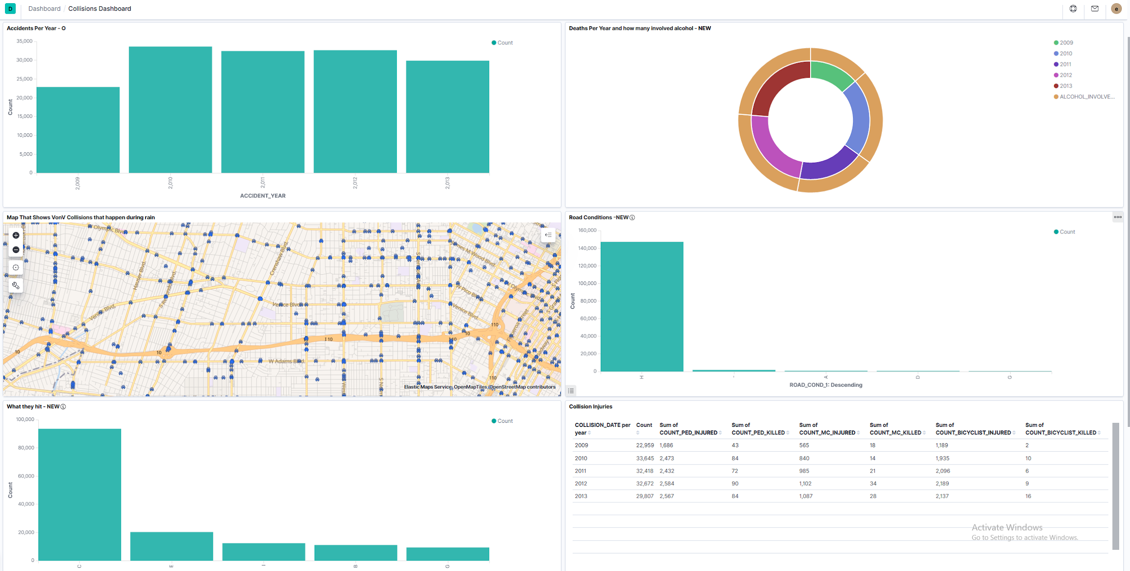

**3. General Instructions**

Our work is based on data collected from the police department of Los Angeles throughout the years of 2009 through 2013. In the data all the information is provided from the date of occurence to the type of injuries that were acquired from the collisions as well as whether a bicycle, pedestrian, motorcycle was involved in the traffic collision. Included in the data was also the exact location of where the accident took place as well as if the driver was intoxicated with alcohol. Along with this was a map that we included, where it plots out all the exact spots where all the collisions occurred, as well as the type of injuries acquired during those collisions. Hence giving a bigger picture and easier to understand layout of the amount of collisions that occur in our daily lives, and how dangerous it is as we go about our everyday lives.

**Graphics:**

**Metrics:**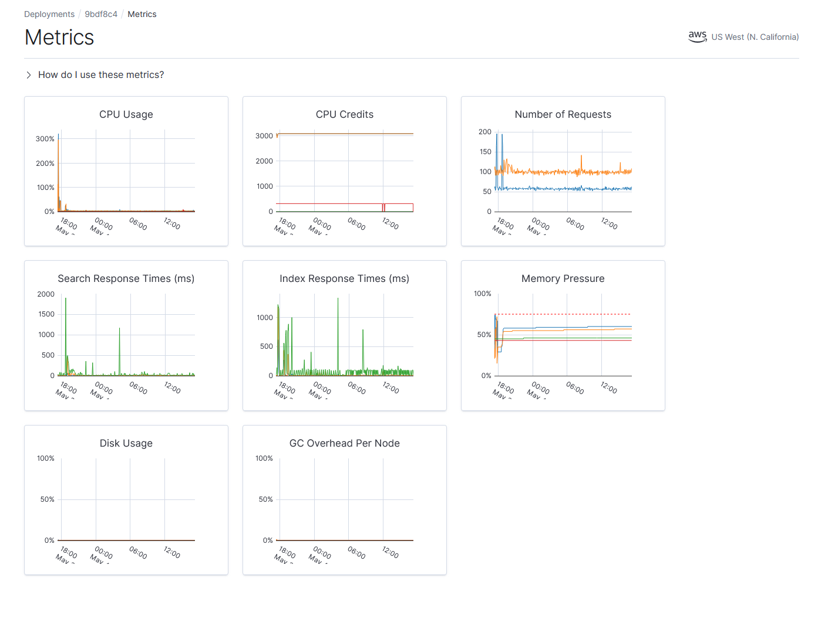

"Figure 1. Metrics charts."

**Collisions Dashboard:**

"Figure 2. Los Angeles Collisions Dashboard"

**Deaths per year:**

The following pie chart showcases vehicle collision deaths for each year, and the number of those that were involving alcohol intake being the primary factor of the collisions.

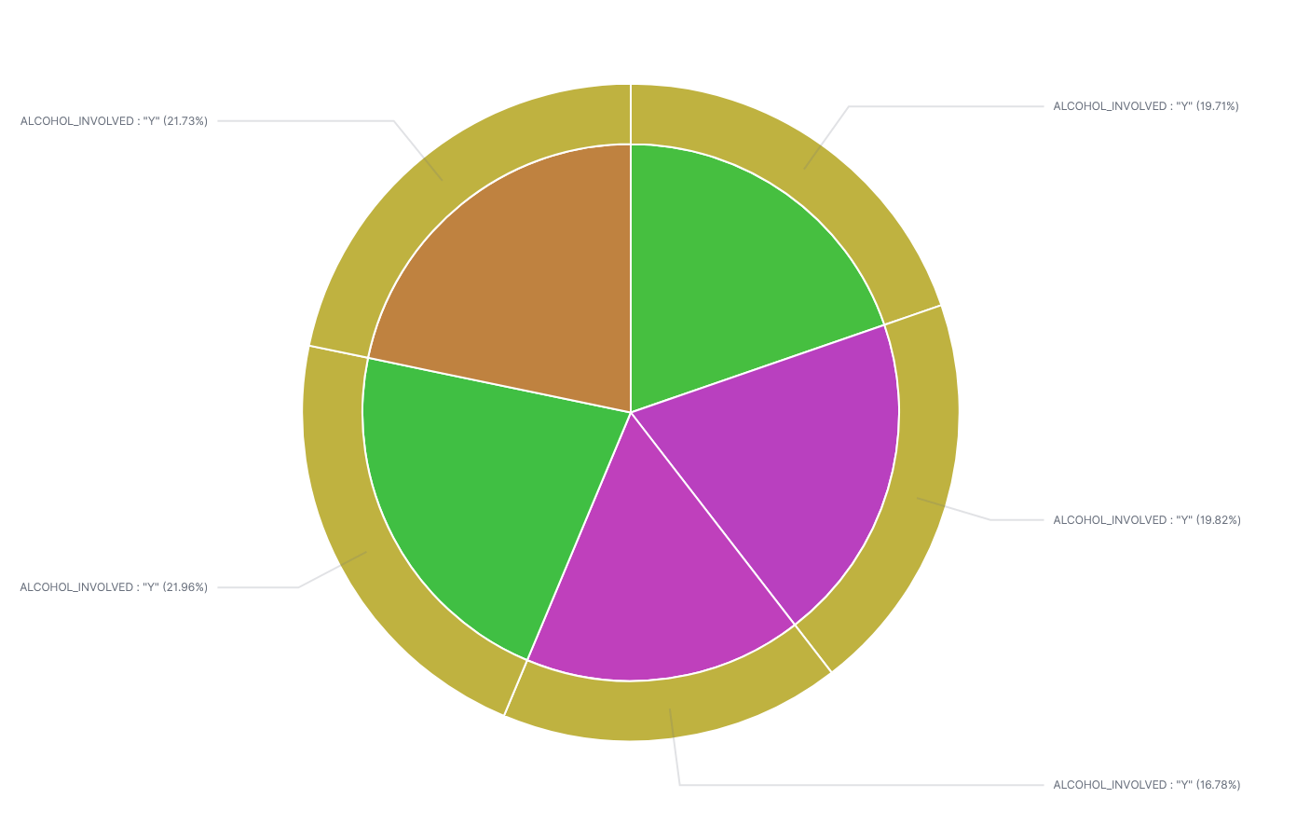

"Figure 3. Pie chart of collisions and alcohol involvement collisions resulting in deaths."

"Table 1. Number of deaths per year, number of deaths per year involving alcohol charts."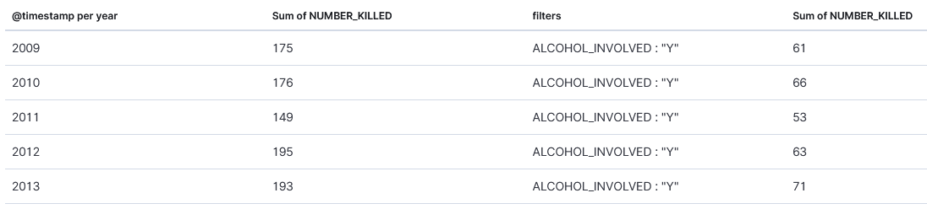

**Weather Conditions:**

The following map showcases plots of all the collisions between two vehicles that occurred during rainy weather conditions.

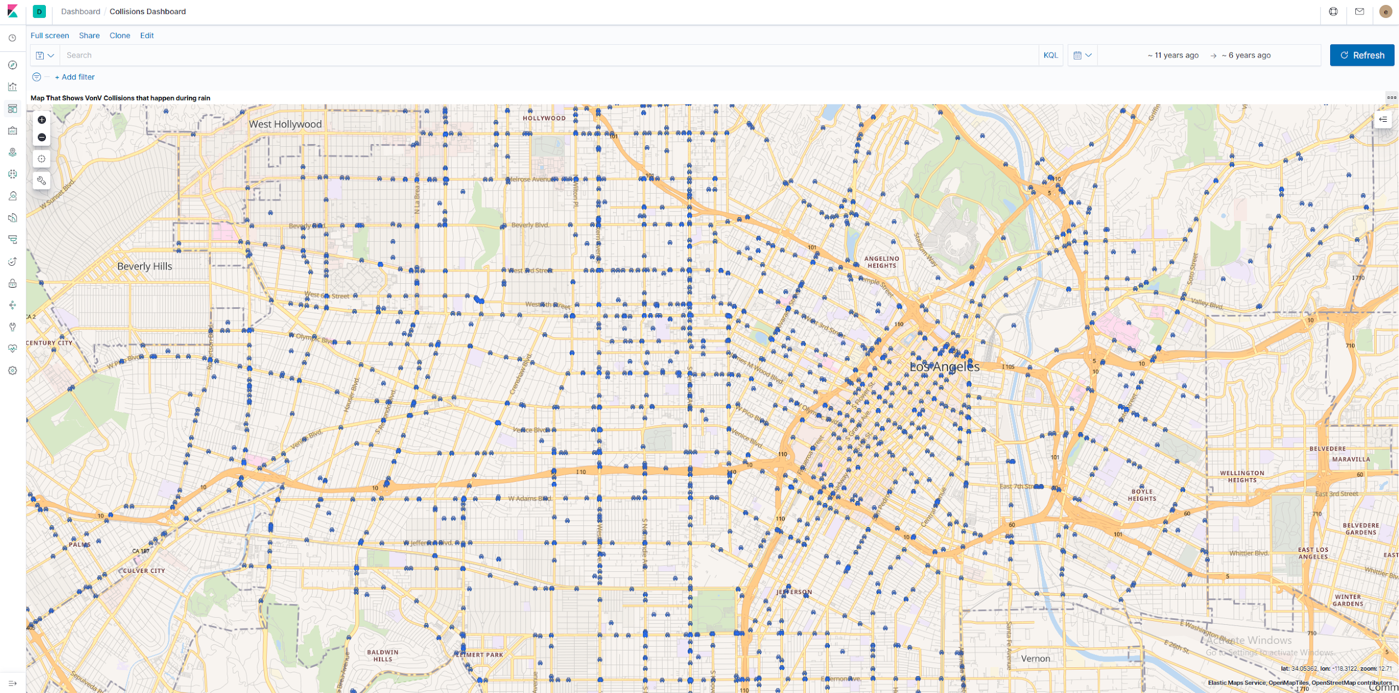

"Figure 4. Collisions during rainy weather conditions.”

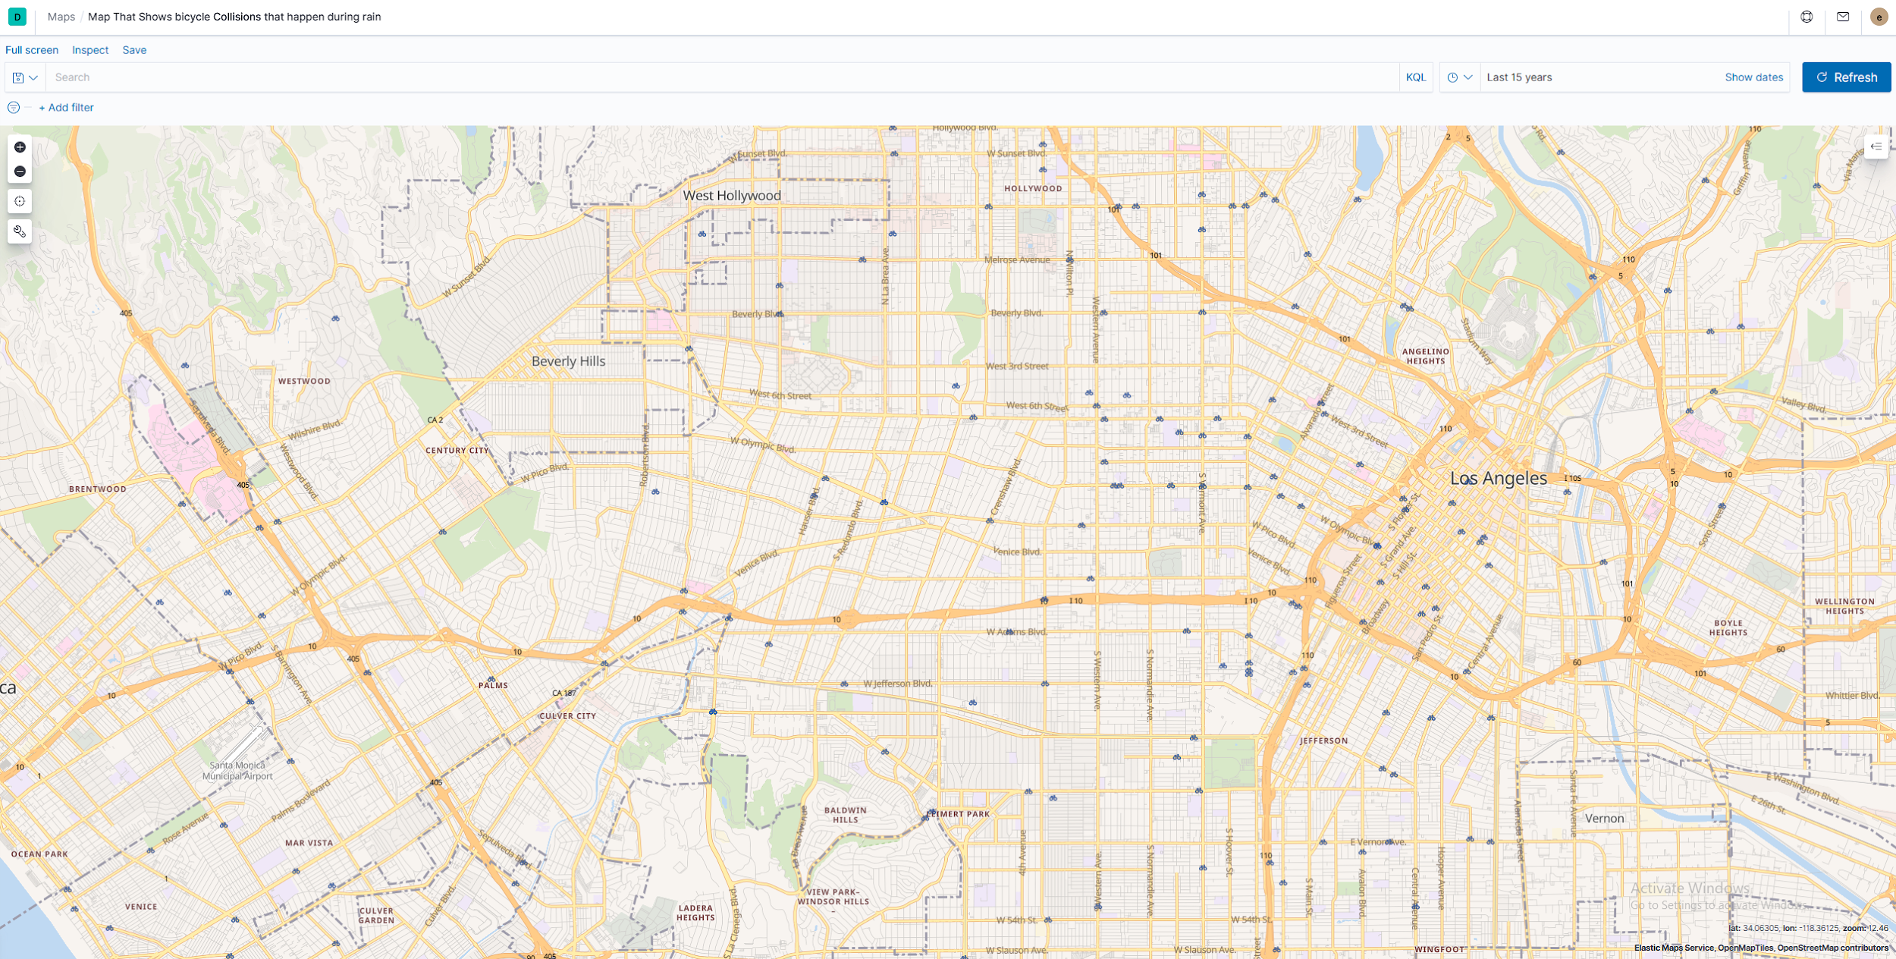

"Figure 5. Bicycle collision during rainy weather conditions."

**Weather and Road Conditions:**

The following bar chart measures the collision severities that were documented after the collisions. The collision severities were documented as follows: 1. Fatal(Death), 2. Injury(Severe), 3. Injury(Other Visible), 4. Injury(Complaint of Pain). The weather conditions also collected data that were addressed on the bar charts. The weather conditions being documented as follows: A- Clear, B- Cloudy, C- Raining, D- Snowing, E- Fog, F- Other, G- Wind--Not Stated. And finally road conditions being documented as follows: A- Pot Holes, Deep Ruts, B- Loose Material on Roadway, C- Obstruction on Roadway, D- Construction or Repair Zone, E- Reduced Roadway Width, F- Flooded, G- Other, H- No Unusual Condition, --Not Stated.

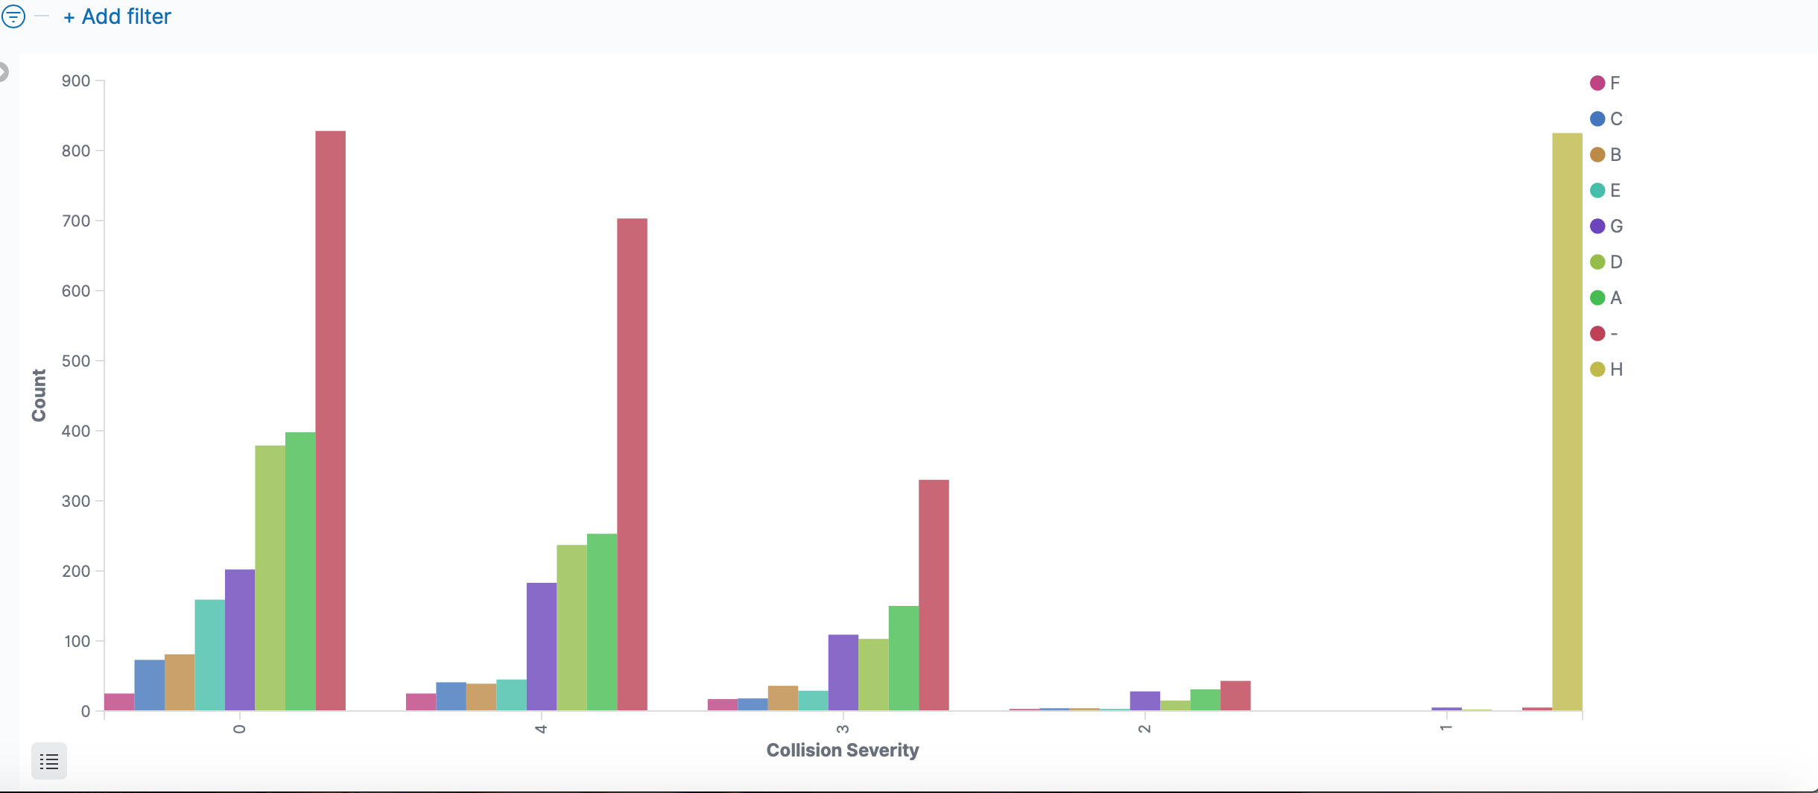

"Figure 6. Collision severity x weather conditions.”

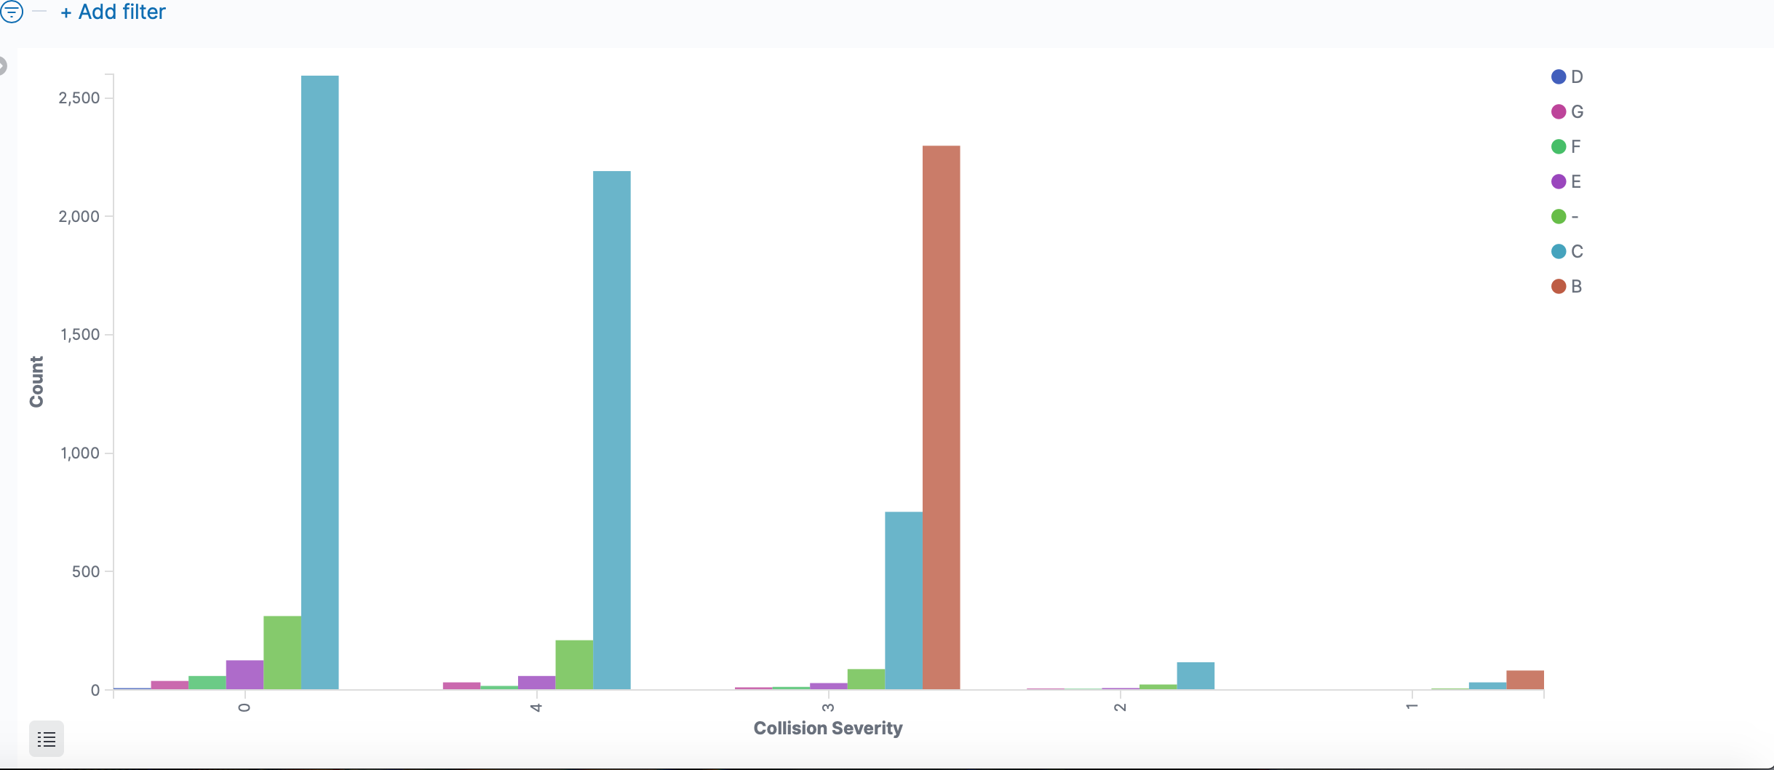

"Figure 7. Collision severity x road conditions.”

**Types of Collisions in Primary Roads:**

Due to the collision severities there were more complaints of pain types of injuries as well as property damage obtained rather than fatal injuries. On Western Ave. there were more visible injuries obtained as compared to Sunset Blvd. Collision Severities were as follows: 1. Fatal, 2. Injury(Sever), 3. Injury(Other Visible), 4. Injury(Complaint of Pain), 5. PDO.

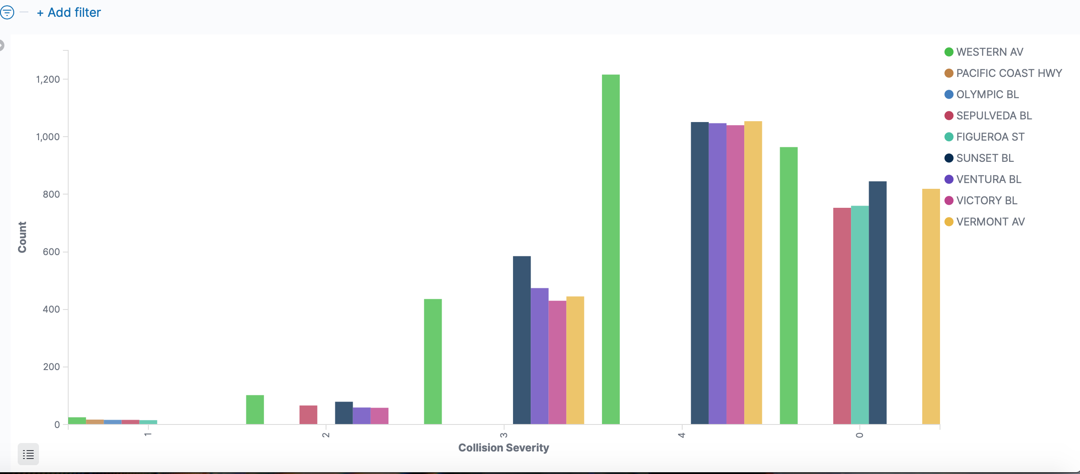

"Figure 8. Collision severity x primary roads.”

**Conclusion:**

We made charts and graphs based on the use of alcohol with the collisions. The correlation between the weather and collision severity as well as the road conditions. We also did graph what streets had what type of collisions, their severity. With the graphs that we have developed and created, a long with the map showcasing all of the collisions that occurred and the exact plots of where they occurred, I believe we provided a great amount of information for everyone. The tutorial that was created was also uploaded on our GitHub where you can take a look at all of our graphs and charts and maps.

I believe that the topic of the vehicle collisions that occurred between the years of 2009 and 2013 are very interesting as vehicle collisions occur very often and with the amount of information we have provided, I believe that we made it extremely informative for the public. The data we gathered and collected to put together can possibly help those who do choose to take a look at it and could possibly save lives or reduce the amount of collisions that occur within the areas that were mentioned in our map through the Los Angeles area, as people will become more careful when going through those streets or may choose to take another route in order to reduce the likelihood of being a victim of vehicle collisions.

I believe that our charts, information, and data that was put together is very accurate as the data we used in order to create our data was documented by a very trustworthy and reliable source. Hence making our work very accurate, as there was no outside or changed information than that gathered from a reliable source.

All in all, the experiment that we created was extremely informative for the public surrounding the Los Angeles area as it provides valuable information regarding their safety on the road, whether one is walking, riding their bicycle or driving. This may also be very important for anyone doing research on such topics as it is very helpful.

**References:**

The sources that were used to finish this experiment were GitHub, which is where we have uploaded all of our graphs and dataset, as well as the tutorial for this experiment to be mirrored by anyone else. Another source that was used was the dataset that was used in order to provide and gather all of the graphs and map putting it all together.

### References

[1] “Practice.” *Ehline Law Firm Personal Injury Attorneys, APLC*, ehlinelaw.com/practice/car-accident/traffic-accident-faq/los-angeles-and-u-s-statistics.

[2] KPCC Documents (Southern California Public Radio. “LAPD Citywide Traffic Data 2019: 1/1 - 12/21.” *DocumentCloud*, [www.documentcloud.org/documents/6595464-LAPD-Citywide-Traffic-Data-2019-1-1-12-21.html](http://www.documentcloud.org/documents/6595464-LAPD-Citywide-Traffic-Data-2019-1-1-12-21.html).

[3]Collisions 2009-2013 (SWITRS). (n.d.). Retrieved from <http://geohub.lacity.org/datasets/ladot::collisions-2009-2013-switrs>

[4] Group 3 GitHub

<https://github.com/CIS3200Group3/Group-3---Project>